PRODUCT TESTING • UPDATED REVIEW

Sandbox testing feedback
  - Dashboard discovery assessment and improvement programme
From Daniel Maneveld | For Dennis | 20 September 2026
The completed dashboard answers several of our earlier questions: it shows CEFR18 detail, a personalised summary, evidence sections, progress, and target reasoning. The main issue is consistency. My dashboard says B2.3 while My Programme says B1, despite the same six numerical scores. Please resolve which placement is correct and ensure the programme uses that result.

Review scope and evidence
This review consolidates Daniel’s walkthrough, supplied screenshots and programme text, and inspection of the LP18 Master Brain Web v6.1 reference HTML. It records observed interface behaviour and open questions; it does not establish that the sandbox uses the reference engine or that its scores are accurate.

Accepted presentation and flow
Area | Positive feedback
Dashboard | Keep the layout. The completed view adds micro-levels, a summary, evidence sections, progress, and target reasoning.
Voice Discovery introduction | Clear introduction, prominent coach video, and skip option.
Discovery topics | Keep the six-topic layout; strengthen the explanation of benefits.
Speaking conversation | Daniel completed the conversation; completed responses appear in its history.
Post-conversation handoff | Clear personalised message, processing status, and next steps.
Written assessment | Separate follow-up is appropriate. Review screen includes four tasks, response counts, Edit options, and one submission button.
Programme presentation | Three phases, activity frequencies, tutor support, and reassessment are easy to follow.

Immediate priorities
First resolve B2.3 versus B1 and check which result drives the programme. Then align the six capabilities, fix existing-company setup, and add live transcription. Earlier blanket concerns about missing CEFR18 detail and rationale are superseded by the completed dashboard.

REVIEW SECTION 02

Assessment framework and dashboard
Required core dimensions: Reading, Writing, Speaking, Grammar, Listening, and Live Interaction.
Item | Required action or answer
Core dimensions | Replace the current mismatched skill set consistently across radar charts, lists, role baselines, results, and programme logic. Confirm whether the mismatch extends into prompts and storage.
CEFR-18 | Micro-levels are visible on the completed dashboard. Carry them into My Programme and Aria’s explanation. Verify the stored result and overall calculation behind B2.3 versus B1.
Numerical scores | Explain score-to-micro-level and broad-band mappings. Some dashboard rows show C1.1 alongside B2; clarify what each label represents. Distinguish capability scores from LP-1000.
Chart meaning | Explain radar rings, bars, and target markers. Fix labels clipped at the left edge.
Targets | The completed dashboard shows C2.1 in the target badge, while its skill target line and My Programme say C1. Explain whether these are different targets or a mismatch. Target reasoning is present.
Missing evidence | Use Not assessed or Insufficient evidence. Missing scores must not become zero or no gap. Preserve results from separate assessments.
Exam messaging | The earlier dashboard showed On track for B1 before assessment, alongside a B2 target. Explain milestone relationships and require evidence for readiness claims.
Live Interaction | Include a capability result and access to the 12 supporting signals, with evidence status. Keep runtime behaviour distinguishable from stable capability.

Reference structure needs reconciliation
The HTML explicitly defines 18 micro-levels from A1.1 to C2.3. Its current capability fields are Listening, Vocabulary, Grammar, Speaking, Reading, and Live Interaction. Writing is handled separately as an assessment modality. Update the reference structure to match Daniel’s confirmed six dimensions; vocabulary and presentation can remain supporting measures.

Speaking and written assessment scope
The discovery conversation is a speaking assessment. No writing task needs adding inside it. Dennis should demonstrate which Speaking, Grammar, Listening, and Live Interaction findings the conversation supports. The separate follow-up tasks supply additional written, reading, and listening evidence.

REVIEW SECTION 03

Voice Discovery and setup

Organisation setup failure
Observed: entering prelabz produced a duplicate-key error for organisations_slug_key. A random company name allowed Daniel to reach the conversation screen. This narrows the failure to handling an existing organisation slug; the exact code path remains unverified.
Action | Expected result
Investigate creation and retries | Check whether each submission creates a new organisation, whether earlier attempts partially saved, and whether duplicate submissions are possible.
Handle existing companies | Support the appropriate authorised joining or linking flow. A matching name alone must not grant membership; separate organisations may share a display name.
Improve error recovery | Replace raw database errors with clear guidance. Preserve entered details and allow safe retry or resumption.
Retest | Use prelabz again, return to setup, and retry submission. Confirm the correct organisation association and no duplicate creation.

Live conversation feedback
Observed by Daniel: completed responses appear, but words do not appear live while he is speaking. Add an interim learner transcript that updates during speech, then resolves to a single completed message. Include a microphone input indicator alongside the listening status.
Dennis to answer: does the speech service supply partial transcripts that the interface omits, or does it only return completed turns? Pass condition: live text appears during speech and finalises without duplicate messages.

Introductory content and consistency
Item | Change
Video duration | Change the 60s label to match the 26-second video.
Coach identity | Use a consistent Aria identity across the introduction video and conversation avatar.
CEFR-18 explanation | Explain that 18 micro-levels within A1–C2 support more precise placement and visibility of smaller improvements.
Discovery topics | Keep the layout. Explain the benefit of each topic. These are discovery topics, not the six capability dimensions.
Learning preferences | Use Learning preferences rather than Learning style. Describe how schedule and feedback preferences shape practice.

Benefits to explain: appropriate task difficulty; role-relevant scenarios; focus on daily responsibilities; identification of difficult interactions; a clear career or role target; and practice that fits the learner’s available time.

REVIEW SECTION 04

Results and improvement programme
Confirmed mismatch: dashboard B2.3 versus programme B1, with the same six scores below. B2.3 belongs within B2; B1 is not a shortened version of it. Neither placement is yet validated.
Displayed dimension | Score | Role gap
Speaking Fluency | 672/1000 | 0
Listening Comprehension | 685/1000 | 15
Writing Formal | 590/1000 | 0
Reading Intent | 541/1000 | 0
Business Vocabulary | 652/1000 | 0
Presentation Delivery | 601/1000 | 0

Finding | Required clarification or fix
Gap interpretation | Five role gaps are zero while C1 remains a goal. Show role-minimum gaps separately from target-level gaps; explain how both influence practice.
Score rationale | Dashboard summary and evidence sections are present. Inspect their contents, then use the same explanations in the programme. Which overall level is correct, and are both pages using the latest combined assessment?
Role consistency | Earlier setup showed Inbound Customer Service; results show Inbound Sales. Daniel to confirm whether he changed it during the successful setup. If not, investigate.
Target consistency | Reconcile dashboard target badge C2.1 with the C1 target line and programme. Explain the earlier pre-assessment B2 default separately; a changed goal after discovery is not itself a bug.
Activity selection | Dashboard summary highlights reading intent and presentation under pressure. Link programme activities to those needs and explain the listening role gap of 15.
Duration and outcome | Was the 16-week plan generated from B1 or B2.3? Explain the duration using starting level, goal and availability. Treat C1 as a goal, not a guaranteed outcome.
Pre-assessment state | A programme and commitment button previously appeared with N/A scores. Label any sample clearly or wait for sufficient results. Fix the placeholder “for your role as your role”.

The schedule currently includes email and speaking practice throughout, weekly tutor sessions from week 5, role-play simulations in the final phase, and reassessment at week 16. Retain the clear structure while validating its fit to the learner.

REVIEW SECTION 05

Live Interaction and verification
Live Interaction requires access to the following 12 signals. For each, distinguish measured evidence, inference, and unavailable or insufficient evidence.
Signal | Question it addresses
Tone Alignment | Does emotional delivery increase or decrease convergence?
Adaptive Shifting | Does communication complexity move toward or away from the receiver?
Frame Integrity | Do participants operate from the same mental model?
Semantic Continuity | Does meaning remain intact across the interaction?
Repair Behaviour | Can convergence recover after disruption?
Cognitive Load Alignment | Is information presented at a processable level?
Response Latency | Does response timing maintain conversational flow?
Turn-Taking Behaviour | Does dialogue support reciprocal understanding?
Hierarchy Sensitivity | Do authority and relationship cues help or hinder communication?
Cultural Continuity | Do cultural expectations remain aligned?
Hesitation Markers | Do pauses reflect healthy processing or communication instability?
Drift Detection | How quickly is divergence identified before convergence is lost?

Checks required to close the review
- Dennis: demonstrate the chain from responses to evidence, CEFR-18 results, identified gaps, chosen activities, and programme duration.
- Dennis and Daniel: verify that dashboard, programme, and lessons use the same saved results and retain them after refresh.
- Dennis: demonstrate evidence coverage for each reported capability and interaction signal. Insufficient evidence must remain explicit.
- Daniel: confirm role and target selections, then review the score explanations against recordings, transcripts, questions, and written answers.
- Joint retest: confirm existing-company setup works and live transcription updates without duplicated messages.
Review status: journey and completed dashboard presentation accepted. Cross-page placement and target consistency, capability mapping, score evidence, telemetry coverage, and programme fit remain open.

REVIEW SECTION 06

Screenshot evidence for conflicting results

Completed dashboard
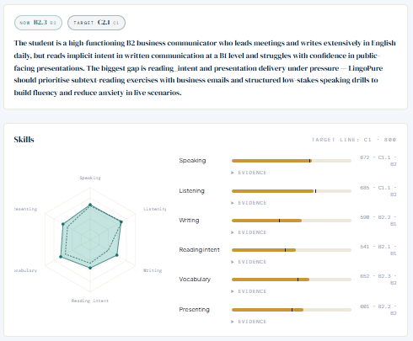
Dashboard: current B2.3, target badge C2.1, and skill target line C1. Micro-levels and evidence sections are visible. Clarify the paired micro-level and broad-band labels within each row.

My Programme after assessment
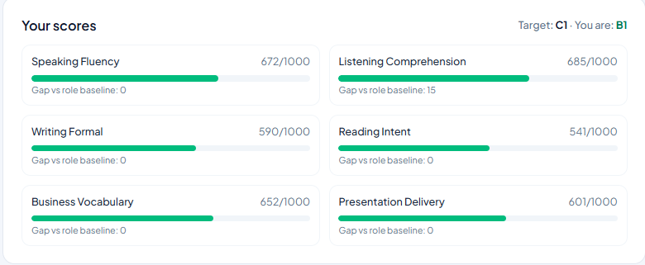
Programme: current B1 and target C1, with the same numerical scores. Dennis to trace both pages to their saved assessment and mapping, then confirm which result drives the plan.

REVIEW SECTION 07

Screenshot evidence for display issues

Dashboard dimensions and target label
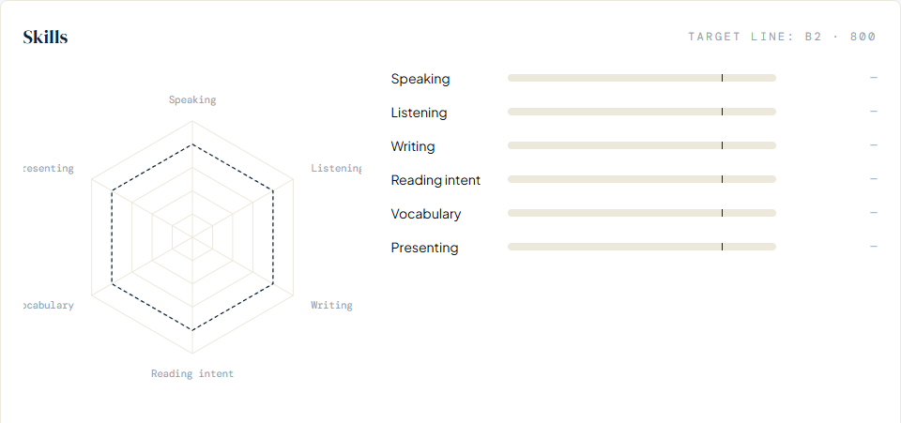
Screenshot crop from the initial dashboard. The visible skill list omits Grammar and Live Interaction, includes Vocabulary and Presenting, and shows B2 alongside 800 without explaining the relationship. Left-hand radar labels are clipped.

Introduction duration mismatch
Two crops from the same introduction screenshot: the heading states 60s, while the video player shows a total duration of 0:26. Correct the label. The accepted page layout can remain.

Evidence interpretation
These screenshots establish display mismatches. They do not reveal whether the underlying assessment uses the same incorrect dimensions or a different scoring framework. Dennis should trace the displayed fields to their source.

REVIEW SECTION 08

Screenshot evidence for setup and speech

Existing organisation blocks setup
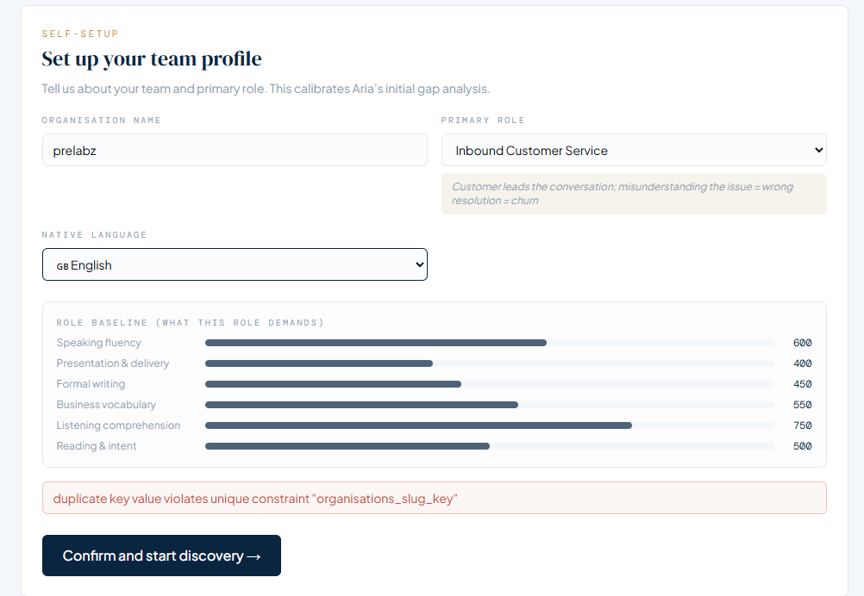
The prelabz entry triggers the organisations_slug_key duplicate-key error. Daniel then used a random company name and reached the conversation screen. The role baseline also repeats the mismatched dimensions.

Completed transcript without live updates
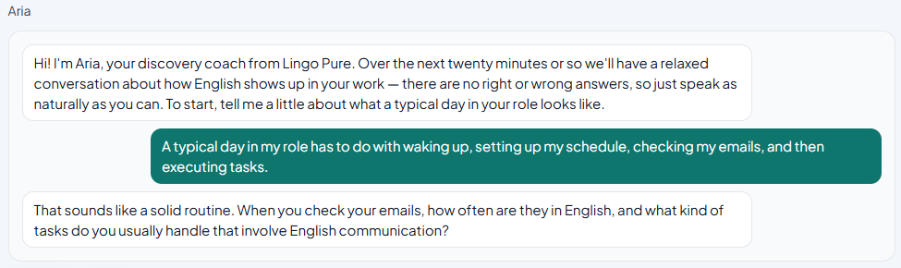
The screenshot shows completed turns. Daniel reported that text did not update while speaking. A static image cannot establish timing; retain this as a user-observed issue and verify partial-transcript behaviour during retesting.

